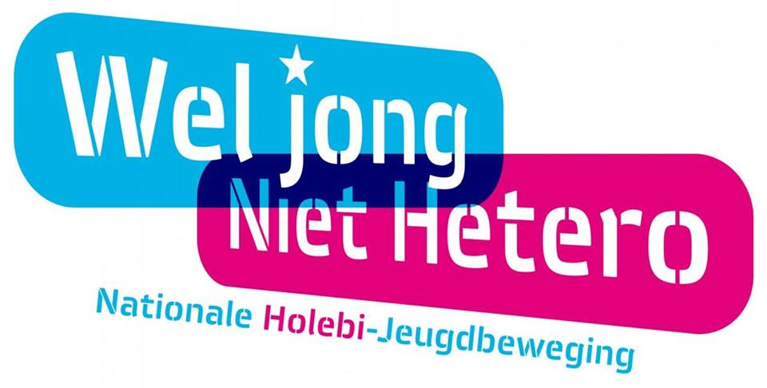
Index
1 TEAM PRESENTATION 3
2 YOUnique Events 4
3 Wel Jong Niet Hetero 5
3.1 Research enterprise 5
3.1.1 Goal 5
3.1.2 Mission 5
3.1.3 Activities 5
3.1.4 Competition 6
3.1.5 Contact information 6
3.2 The analysis of the briefing 7
3.2.1 Date and time 7
3.2.2 Budget 7
3.2.3 Goal 7
3.2.4 Location 7
3.2.5 Target audience 8
3.2.6 Theme 8
3.2.7 Catering 8
3.2.8 Animation 8
3.2.9 Staff 8
4 Project result 9
4.1 The 50’s Recruitment day 9
4.1.1 The 50’s 9
4.2 50’s After Party 12
5 Risk analysis 14
5.1 Recruitment day & Afterparty 14
6 Cost estimation and fee 15
6.1 The 50’s 15
6.1.1 Statutory provisions 15
6.1.2 Communication 15
6.1.3 Staff 16
6.1.4 Catering 16
6.1.5 Technique 17
6.1.6 Decoration 17
6.2 Afterparty 18
7 Conclusion 17
8 Supplement 18

TEAM PRESENTATION
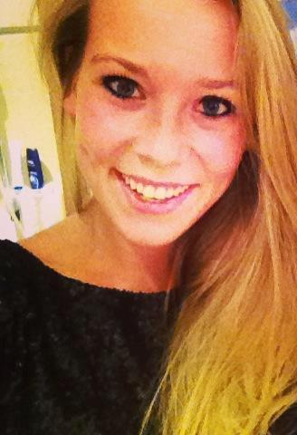
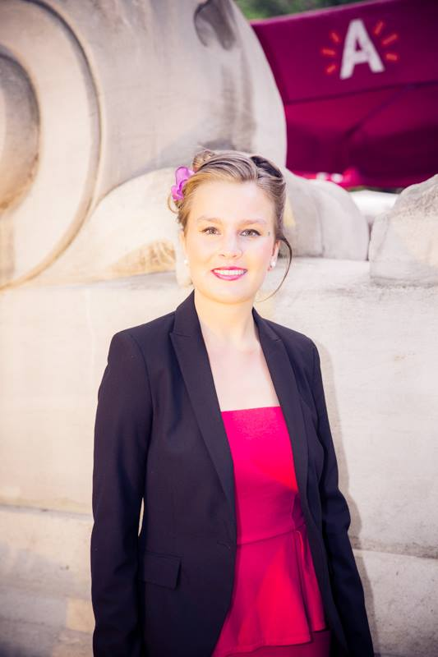

Sharon Van Goethem Tinne Sweeck
Team Leader & Event Manager Event Manager
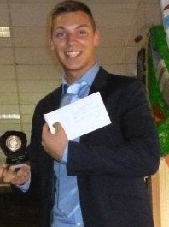

Kevin Mestdagh Bryan Van Noolen
Financial & Event Manager Creative & Event Manager
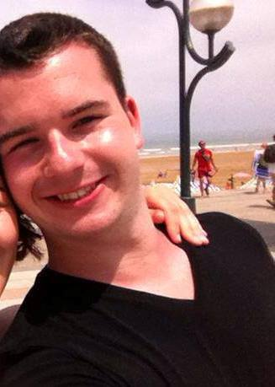
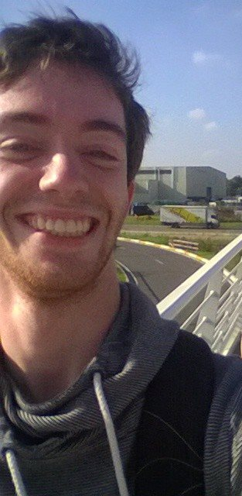

Nick Luyckx Jamie van der Jonckheyd
Event Manager Event Manager

YOUnique Events
Name
You can divide it in 2 obvious words. ‘You’ and ‘unique’. It is a pun.
The name came up spontaneously. YOUnique Events means we operate with a personal approach. It is common in an event agency to be like this but YOUnique Events is always a step ahead of its competition. Our core exists of the idea where your home, your habits and your way of thinking is put on top of the list. We want to give all participants and guests to feel if they were at home. Comfort and luxury is what everyone deserves and it would be an understatement if we said we are 100% dedicated to our job.
Logo
We needed a logo that reflects happiness. By using many matching colours one does feel much more positive than using a cold and one colour. You automatically enjoy the image of our logo. Not only for the colours but also the lollipop and also this is used for a purpose. Not that we are a candy shop but it came our mind to express happiness. Have you ever seen a sad kid with a lollipop like that? The answer is simply no.
That means our target audience is merely kids? No, not at all. It came from a metaphor. In every adult hides a child. We all still dream of our years as a kid. The freedom, the passion etc. everything was brighter, everything was just more simple than being an adult. We want to give you that satisfaction and every time we will do our best to give you the opportunity to live like a kid on the playground away from all what is negative.
Slogan
“A unique view on all your events”
Your event is viewed from different perspectives. To this we mean that the personal communication and relationship with the customer are our highest priorities. We denote your event visually through presentations so you have a perfect and of course a unique view on your event.

Wel Jong Niet Hetero

Research enterprise

Goal
Wel Jong Niet Hetero is an enthusiastic partner for the LGBT-community. They focus on young people up to 30 years. The goal of this organisation is that every young person in Flanders and in Brussels can express their sexual orientation freely.
The organisation has been active since 1994 and is literally present everywhere. The head office is located in Ghent. In addition, they are also still active in other provinces. In each province is a connected local group, which is also autonomous and work with volunteers. Thanks to these local groups, LGBT young people find their way to a nice association. Inside this association they can be themselves, completely without prejudice. In addition, there are 5 national teams: Plan B, T-Jong, Min19, Team VVB and NT Online.

Mission
The Mission of Wel Jong Niet Hetero states: "Wel Jong Niet Hetero is as partnership the competent partner in the field of LGBT theme among young people up to 30 years, with the aim that every young person in Flanders and Brussels can experience his or her gender identity, gender expression and sexual orientation in complete freedom."

Activities
Lend an ear to
The local groups are always ready for their members. So they organise many fun activities, but they are also listening to young people who have it harder with their sexual orientation. It is also called the ideal environment to make friends and to expand networks.
All this is directed through a small and motivated team consisting of staff members and volunteers from all over Belgium.
Forum
For everyone there is something. Even for young people who do not feel accosted to these local groups there is a solution provided. So does Wel Jong Niet Hetero offers a comprehensive forum to where you can go for answers to all your questions. There is also the possibility of getting to know other LGBT people too and to amuse you.
Range of activities
Wel Jong Niet Hetero also dispose of a range of activities for young people younger than 19 years old. T-Jong is ready for transgender youth thanks to the team of Min19. There is an annual Expedition Y camp provided and young people are also found on all kinds of events such as the annual Belgian Pride which takes place in Antwerp.

Take care for a better world together
Wel Jong Niet Hetero calls itself an idealist. They try to make the world (or at least Flanders and Brussels) just a little better. They do this by ensuring that LGBT and transgender young people are self-confident and that they feel safe in the society.
The organisation coordinates many initiatives that try to sensitize the society such as the awareness-raising campaigns to the education, the schools, and the formation. They also encourage LGBT people outside in youth work such as youth movements and they make sure that the association is visible in the media. Nevertheless, there is still gay and transphobic violence in Flanders and Brussel.
Make an appeal to volunteers
Realize these objectives are not simple. Wel Jong Niet Hetero can count on subsidies from the Flemish Government, but this is not enough to fully support the operation. With this subvention only the executives can be paid. That is why Wel Jong Niet Hetero appeals to volunteers. Everyone is considered to support the organisation and to contribute.

Competition
- http://ww5.holebi-limburg.be/
- http://www.sensoa.be/
- http://www.planetgender.com/
- http://www.lingam-workshops.be/
- http://2011.mikpunt175.be/
- http://www.dubbel-zinnig.be/
- http://ertussenin.wordpress.com/
- http://www.sheshebar.be/
- http://www.anders-gewoon.be/
- http://www.berdache.be/
- http://genderflux.blogspot.be/
- http://www.gewoon-doorgaan.com/
- http://transgenderkring-vlaams-brabant.be/

Contact information
Wel Jong Niet Hetero VZW
Kammerstraat 22
9000 GHENT
Phone: +32 093 35 41 87
E-mail: info@weljongniethetero.be

Doreen De Greef
Educational co-worker
Phone: +32 484 09 95 25
E-mail: doreen.degreef@weljongniethetero.be

The analysis of the briefing
After thorough analysis of the briefing we have raised a few questions to the enterprise Wel Jong Niet Hetero on various subjects. The essence of this is discussed below.

Date and time
The event will take place in March 2015. Though it is certain that the event will continue over the weekend on Saturday 28 March. For the event itself, it can be pulled out a full day. The event will take place from 10am until 5pm for the recruitment day.

Budget
A budget wasn’t really provided therefore we do not take into account an advanced featured budget. The recruitment day aims to recruit new volunteers. It would therefore not be lucrative to make it a paying event. The entrance is expected to be free.

Goal
The main objective of the event is, as previously cited, recruiting new volunteers who are enthusiastic to commit themselves for one of the national teams. It goes without saying that it is important that the recruited volunteers can identify in the values and the standards, as well as the vision of Wel Jong Niet Hetero. These can be consulted on the website www.weljongniethetero.be.
.
The most important aspect of the recruitment day is that potential volunteers know the operation and can obtain enough information about the national teams. Including who they are, what they do and who the audience is

Initially it is an informative event, but also here Wel Jong Niet Hetero stands op to other ideas. Having regard to the fact that Wel Jong Niet Hetero is an association with young people (16-30 years old) as a target group, they always try in some way to have a young and fresh look. At the event there might be a playful character. Therefore, networking should also sure to be covered.

Location
What concerns the location we can appeal to Event City. Event City is located adjacent to the Trafford centre, next to Barton Square. The location has 4 halls with a floor space of 28,000 square metres, all on one level. The address is Phoenix Way, Off Barton Dock Road in Manchester. They have more than 400 toilets foreseen over all the halls. Also there are more than 3000 free car parking spaces. More info can be found at http://www.eventcity.co.uk/venue-info/?MenuPage=437.

Target audience
This recruitment day is organised for young people aged 16 to 30 years for the volunteers and also for every passer-by. Wel Jong Niet Hetero has no expected number of attendees but hopes for a great response.
The communication strategy to the target group will be worked out by Triple G-agency. The recruitment day will also be used in addition to reach externals that still haven't heard of Wel Jong Niet Hetero or externals that aren’t yet connected.

Theme
The theme is 'the 50s'. Wel Jong Niet Hetero is thinking about a market system in which each national team has a 'booth' where several volunteers of the teams in question gives explanation to the visitor. Further information can be found in the project result.

Catering
In the idea of the market system where people come and go, according Wel Jong Niet Hetero there is no need for a catering because no one would stay very long. A small snack and a drink, however, it’s always nice as long as it remains within budget. YOUnique Events is free to choose the style of catering.

Animation
Every “booth” would also be equipped with 2 persons per stall that assists the visitor with a word of explanation. If the concept is changing, this can of course also still change. If a presenter would be needed, Wel Jong Niet Hetero will do this.
The national teams must be involved in the recruitment day. Although this teams of Wel Jong Niet Hetero are to a certain extent, they function autonomously.
The task of Mrs De Greef, educational co-worker, is to support the teams. It is therefore crucial that the coordinators of all the teams are present on the day itself. All teams are also aware of the fact that the recruitment day is organised by an event agency. At this stage of the project, the communication runs the best through Mrs De Greef.

Staff
If the concept of the stalls will be remained, they will be staffed by the volunteers of the national teams. Welcome by Mrs De Greef and other members of the management. The information in the halls will be given by the co-workers of Wel Jong Niet Hetero and a lot of animation will be provided.

Project result

The 50’s Recruitment day
We have worked out our concept for the recruitment day in a day concept and an after party. With the concept of ' Fifties ', we have used our creativity. At the ' after party ' we have taken into account all the inhabitants of Manchester.

The 50’s
Theme
Today LGBT people have built up a lot of legal rights. The social acceptance is now big, but this has not always been the case. In the 1950s it was taboo to be gay. Its existence was even denied. The theme 'Fifties' on the recruitment day responds to the controversy and throws all the clichés and taboos on a heap. More than enough topic of conversation!
The reception
When guests enter the event, they are warmly received by Doreen De Greef, educational Assistant of Wel Jong Niet hetero. The first contact will be warm and friendly. Every guest gets a word of explanation about Wel Jong Niet Hetero, the course of the event and the layout of the spaces. Meanwhile, guests can enjoy fruit juice, tea, coffee, in the afternoon cava and there will be snacks that are offered.
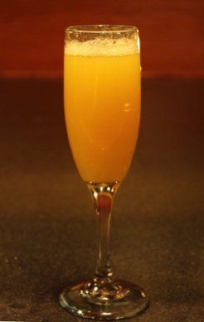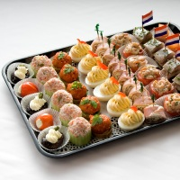
The interior design
Hall 1:Lounge
In the first hall there will be a salon be equipped. This salon will be fully decorated according to the theme 'fifties'. We work with an old TV screen. On this screen will be played a movie of the evolution of the organisation Wel Jong Niet Hetero. Further there will be all the necessary decoration material present including old lamps, 50's seats, a coffee table and the etc.

Hall 1: Bar
Our bar is decorated "à la Grease'. The bar is transformed into an American dinner with high-top tables where guests have the opportunity to network thanks to a playful 'taboo' game. Furthermore, in this space is also a jukebox where guests can request their favourite fifties songs. You can also enjoy the atmosphere with a lovely milkshake, tea, coffee or a hot chocolate milk while you get served by our overjoyed waitresses on roller skates! It is like you are in your own movie!
The space next to the bar is transformed into a hair & makeup booth. Here guests can let take care of their hair by a professional hair & make-up artist in the ' fifties' theme. You will look even more splendid with your new trendy look!
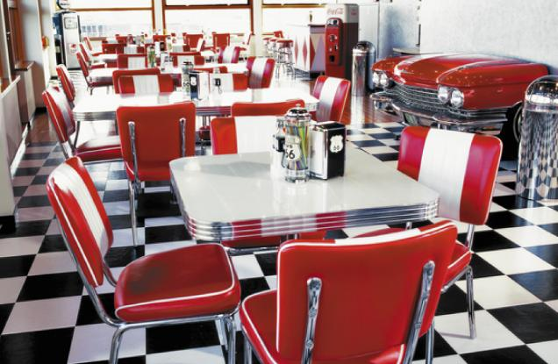
Hall 2: Information room
Hall 2 is fully equipped as an entrance hall. This means that there will be a doormat at the onset of the room. There will be also an umbrella holder and a gramophone. On the wall there will be nice picture frames with black-and-white photos of the Wel Jong Niet Hetero team. In this way we create a real homely atmosphere.
In the middle of hall 2, there are a large seats. Guests can relax and enjoy some snacks and drinks.
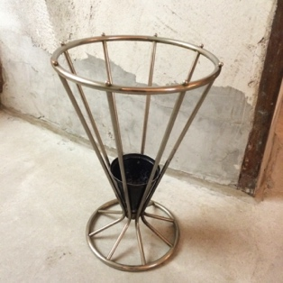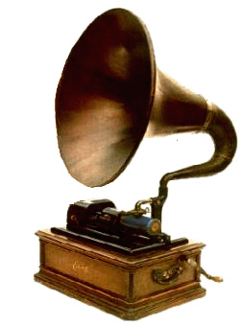

Hall 2: Catering
During the event the following drinks (at low prices) are present: Cava, white wine, red wine, a range of Palm beers, fruit juice, soft drinks and water.

In addition to this extensive selection of drinks the attendees will also be spoiled with all sorts of goodies. There will be cold and warm snacks by J&M catering. Different waiters will go through the halls with plateaus with numerous delicacies during the entire event. J&M catering obtained quotation can be found in annex 1.

Animation

Hall 1: Hair & make-up artist

As already mentioned, guests can enjoy a hair and make-up turn. All present staff will also be handled by the hair & make-up artist so the fifties experience will be even more authentic and the visitor will be completely in the atmosphere and the thinking behind the concept.

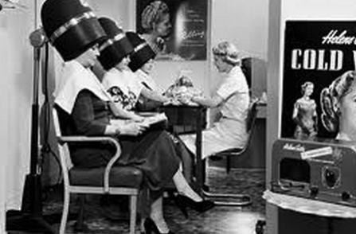

Hall 1: Taboo-game

If there is a cautious atmosphere, guests will be encouraged to talk with each other thanks to our self-designed taboo game. There will be some cards on the tables at the bar which are topped with a word or question. This word must be explained to the group without using some "forbidden words". The questions range from real knowledge questions to fun and stereotype-questions in the LGBT theme.

Hall 1: A gaming-corner

In the beginning of hall 1 there will be a gaming-corner equipped for the children. A lot of volunteers of the organisation Wel Jong Niet Hetero will give workshops and play games with the children. There will also be a stall for pancakes and waffles in case that the children are getting hungry.

Hall 2: Tablet wall

In hall 2, there will be different tablets affixed to the walls. In order to remain in the atmosphere of the 1950s, there will be placed a classic photo frame around each tablet.

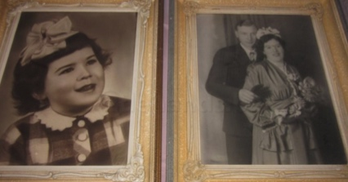
There will be movies be shown of LGBT people who each do their personal story. As a guest, the aim is to answer a question about the told story. Based on this, the story is told in a different way. At the end of the story the visitor receives feedback on the choices and an 'ability-score'. At the frames there will be different speakers placed for a word of explanation that can be requested. These speakers are also dressed and cut down according to our chosen theme. In addition, there will be quiet music played in this whole area.

50’s After Party
Intro
After de day filled with workshops we organise an after party. The purpose is to have a nice ending of the day. The LGBTs can come party alone or can come with their families.
Event specifications
We’ll organise our after party at the Event city Manchester.
Vital statistics
Area
At the Event city venue there are 3,000 free parking spaces so everyone can park nearby. It is accessible by all forms of transportation. There are over 1,000 hotel rooms within 1,000 meters, so people can book a room to stay there after the party. People who join the party will have a discount in the hotels nearby.
Hall
We’ll give the party in Hall 4. This Hall has a floor space of 6,000 square meters. There are 78 toilets in total. Extras for hall4. There is star cloth to all walls. There is trussing and dividing rigging points. We will demarcate a part of the room, so if there are not many people it won’t feel empty. When there is more people we will open it up and it doesn’t feel too crowded. There is a state of the art sound system. At the event there will be a technical manager to help with problems.
Event concept
Our party will bring you back to the 50’s. It will take you back to the Beatles, Hippies, Peace signs, Afros and more. With the flower power decade of music playing and many impressive props, this event is sure to give you a great time.
Guests arriving at the 50’s theme night will be welcomed with drinks by Sixties dancers handing out colourful flowers, the 1950’s feel is only emphasized further as they take in the themed 50’s scene by our fantastic 50’s theme props.
There will be sixties dancing girls and boys who keep all entertained on the music that works through the decade of the 1950’s.
These are some of the props: Huge pillars with 1950’s Flower power signs, 1950’s silhouette figures of John Lennon, Marilyn Monroe, and others, Neon light signs, Retro arcade games, giants 1950’s shoe, camper vans with lounge.

Message party
At our after party we will also organise a message party. When people enter the get a sticker with a number. The sticker will have the colours: green (single), red (in a relationship) or orange (net defined). The also get a bracelet with: Straight, Gay, Lesbian, Bi-sexual or Transgender.
There is a panel with number, people can write something to someone and put it in the box of the person with the matching number. People can then get the message out the box. You can anonymously write a message or put your number/name on it.
Bar
Bar personnel is included in the price of the event location. The prices will not be high for drinks. Soft drinks will be rather cheap. We get 15% on the drinks consummated.
Music
We will have live groups who will bring famous songs of the 50s. Afterwards there will be a DJ who mixes 50s music with modern music.

Risk analysis

Recruitment day & Afterparty
Cause | Result | Emergency plan | Type of risk
Too few attendees. | There is too little to eat and drink, as a result, we get no matter the cost. | Good communication plan and realistic cost-benefit analysis. | Organisational and financial
People are fond of their privacy. | The attendees haven’t the intention to speak with each other, this results in a cautious atmosphere. | On the basis of a taboo game, there will be discussed all kinds of topics. | Corporate Social
Power Failure. | Tablets, TV and sound system are no longer working. | Scenarios are further told by the volunteers. | Technical
Security problems by staff shortages. | Panic and unprofessionalism | People assume that guarantee the security (including police) | Technical
Bad weather. | Visitors are less enthusiastic. | Indoor event in the place of an outdoor event. | Environment
Protests against LGBT. | Unrest during the recruitment/information day | Police will be switched on. | Corporate Social

Cost estimation and fee

The 50’s

Statutory provisions
PRS

PRS

Description | Price
Total | £125.49
Discount E-licensing | £1.84
Amount of VAT | £8.02
TOTAL AMOUNT VAT INCLUSIVE | £135.35

Royalties

Description | Price
Inside – no dancing – with music VAT exclusive | £377.07
TOTAL ROYALTIES | £377.07

Communication
Description | Price
Triple G-agency | £ 1000,00

Staff
Wel Jong Niet Hetero – team

Description | Amount | Unit price | TAV | Total
Doreen De Greef - info | 1 | - | - | -
Speakers | 10-15 | - | - | -

Hair & make-up

Description | Amount | Unit price | TAV | Total
Hair & Make-up artist | 1 | £257.21 (TBA) | - | £257.21
Margin of uncertainty 15% | £52.20
TOTAL | £309.41

Description | Amount | Unit price | TAV | Total
Animators | 10 | - | - | -

Catering
Description | Amount | Unit price | TAV | Total
Material | - | - | - | -
Staff costs (extra) | 4 hours | £25.71 | £5.40 | £124.49
Cocktail ‘Select’: 1.5 hours | 100 | £16.75 | £3.52 | £2,027.62
Margin of uncertainty 15% | £322.82
TOTAL | £2,474.93

Description | Supplier | Amount | Unit price | Unit TAV | Total
Formula 1b  Pancake stand  Waffles from Brussels & Liège  Sugar, whipped cream  Chocolate sauce  Incl. set up stand  Service  Napkins | Paris Royale | 1 | £419.52 | - | £419.52
Margin of uncertainty 15% | £62.93
TOTAL | £482.45

Technique
Description | Supplier | Amount | Unit price | Total
Jukebox | Jukeboxplezier.be | 1 | £216.77 | £216.77
Background music | Mint Creations | about 10 | - | -
Audio installation | Geluidsinstallatie-huren.be | 4 | £36.74 | £146.96
Tablet | Infotheek.com | 4 | £14.70 | £58.80
Social media “matching module” | Mint Creations | 1 | - | -
Transportation cost | £21.17
Margin of uncertainty 15% | £63.39
TOTAL | £507.09

Decoration
Description | Supplier | Amount | Unit price | Unit TAV | Total
Wooden clothes hangers | Fonq | 2 | £20.01 | £4.62 | £24.63
Old television screens | 2dehands.be | 2 | £14.70 | - | £14.70
Old photo frames | 2dehands.be | 5 | £7.35 + 5.51 + 5.51 + 5.88 | - | £24.25
Chandelier | Restorent.be | 4 | £7.35 | £1.54 | £8.89
Candles for chandeliers | IKEA | 20 | £0.58 per 4 | £0.03 | £3.05
Block candle | IKEA | 10 | £0.60 | £0.13 | £7.30
Cocktails in neonlight | Alterego | 1 | £49.98 | - | £49.98
Lamp | Kapaza | 1 | £7.35 | - | £7.35
Unique curiosa lamps | 2dehands.be | 2 | £31.23 | - | £31.23
American-diner, bar chair | Alterego | 6 | £13.60 | - | £13.60
American-diner, standing table | Alterego | 2 | £22.05 | - | £22.05
Bench Julius orange | Classicdesignrental.be | 2 | £22.05 | £4.62 | £26.67
Cottage ottoman | Classicdesignrental.be | 2 | £18.37 | £3.85 | £22.22
Bar table  with stretch slipcover | Partykel Rent | 6 | £9.18 | £1.92 | £11.10
Transportation cost | £168.76
Margin of uncertainty 15% | £84.21
TOTAL | £769.36

BASELINE | £6,525.15
FEE 25 % | £1,631.29
COSTBUDGET | £8,156.44

Afterparty
Location | £1319.55
Lights | £439.85
Decoration | £586.47
Dj/bands | £1099.63
Promotion material | £169.96
Extras | £73.31
Music license | £283.42
Event insurance | £113.42

BASELINE | £ 4,085.61
FEE 25 % | £ 1,021.40
COSTBUDGET | £ 5,107.01

Conclusion

Our goal is to provide for your needs and wishes. If you are happy that means we have done our job and we can’t get more satisfaction of a happy customer. Together we will offer you guests what they desire and give them a daydream that will never be forgotten!
Our target audience is pretty much everyone who wants to organize a unique, fresh and outstanding event that will attract even the most pessimistic people because not only do we help you organize we distribute a good relation between us and the customers and we build up your event in an amazing storyline. Our result will be out of this world! You won’t even notice you are at work.
Our theme will be the fifties. So put on your dancing shoes because we are going to party in style!
We think outside the box so also we offer a wide range of animation. You can go to the hairdresser for a trendy fifties look, you can buy the popular a lot of drinks in our retro bar, you can attend the ‘taboo game’ and there is so much more the guests will discover! As finishing touch we want to give all the attendees a special experience from our Belgian cuisine and of course we serve the typical English dishes for the people who don’t like changes.
We want to make sure every attendee will remember this event and also the organisation ‘Wel Jong Niet Hetero’. Also games between our guests will make it more exceptional and creative.
For this event we choose the best venue in Manchester, Event City! This will be the talk of the show, the cherry on the pie. It will be a dream come true. It is an understatement to say this will be the most majestic information and recruitment day!
We are truly convinced that you and your guests will go home with a smile on your face by our well thought furnished and creative concept but at the same time realistic. The people will not only enjoy it, they will have gathered a ton of information that will help them in the future involving their selves, their family, their friend(s) and so on. And for you, this event will also be very effective to recruit volunteers for ‘Wel Jong Niet Hetero’.

Supplement
Supplement 1: Annex of J&M catering

Description | Quantity | Unit Price | Taxes | Total

Formula: Cocktail ‘Select’
Open bar

Cava Brut Reserva

White wine: Torre Del Gall Pleyades D.O. Carinena Macabeo Blank

Red wine: Shiraz Tinto D.O. Carinena Pleyades

Range of Palm beers

Orange juice

Soft drinks

Water

Coffee

Thea

Milkshakes

Range of cold snacks (2 per person)
Lollipop of goat cheese, pineapple and Elixir d'Anvers
Spicy lentils with Greek yoghurt and coriander Antwerp glory: Crispy rye damn, evantoh, mustard and pickle
Brine herring ' Maison ' with young beets and Dill Bonbon of cauliflower, herring caviar and chives

Assorted hot snacks (3 per person)
Crispy shrimp with sweet chili nobashi maison Lacquered skewered chicken, Lemongrass and peanut Lamskofte, hommous, cumin, salt, lemon and pomegranate
Candied Norwegian salmon airy vichyssoise potato leek and egg with flavors of sweet and sour, curry and hazelnut
Material included in the price | - | - | - | -
Personnel costs (extra) | 4 hours | € 35,00 | € 7,35 | € 169,40
Cocktail ' Select ': 1.5 hours | 100 | € 22,80 | € 4,79 | € 2759
TOTAL |  |  |  | € 2928,40

